HIGH LIFE HIGHLAND  REPORT TO BOARD OF DIRECTORS  28 March 2013 | AGENDA ITEM 13 REPORT No HLH 7/13

Quarterly Performance Report - Report by Chief Executive

Summary

The purpose of this report is to present performance information for the period December 2012 to February 2013.

It is recommended Directors comment on the report and agree that the overall health check on the company is assessed as green.

1. | Business Plan Contribution
1.1 | This report will assist the Board in monitoring performance against all of the business outcomes in the Business Plan and will provide an overview of the performance of the organisation.
2. | Background
2.1 | At the September 2012 meeting Directors agreed that its high level performance monitoring should focus on ten business critical areas.
2.2 | Appendix A contains the summary of performance against the performance indicators. Appendices B and C contain further information on the indicators.
3. | Summary of performance
3.1 | Eight of the ten indicators have been rated as being on target with two not having been rated, as they are scheduled for rating in June 2013.
4. | Risk
4.1 | There are no new risks identified as a result of the production of this report.

Recommendation

It is recommended Directors comment on the report and agree that the overall health check on the company is assessed as green.

Signature:

Designation: Chief Executive

Date: 18 March 2013
Business Critical Indicators - Summary Appendix A

Business Critical Area/PI | Reporting Frequency | Performance Assessment Method | RAG* Rating November 2012 | RAG Rating February 2013 | Summary of Performance: February 2013
- High level relationship with THC | Annual | Annual meeting, with one of the agenda items to be “assessment of the relationship between HLH and THC”, between:  - the HLH chair, vice chair and the chair of the HLH Finance and Audit Committee; and  - THC’s Leader and Budget Leader | G | G | The assessment of the HLH Chair is that the relationship between HLH and THC is positive for the following reasons:  - The process of agreeing budget savings, while difficult, has been successful;  - HLH has taken account of new THC corporate and service plans in its business plan;  - The successful addition of new facilities into the SDC: Aviemore; Averon; Culloden;  - THC has asked HLH to participate in the development of the new Children’s Plan, “For Highland’s Children 4”;  - The ECS Service has funded HLH to provide a temporary post in Alness Academy to support pupils through providing additional youth work;  - The ECS Service has funded HLH to provide additional youth work support for young people who have employment activity agreements.
- Delivery of the SDC with THC | Twice per year | Agreement of THC’s Culture and Leisure Contracts Scrutiny Sub-Committee that HLH has met the terms of the SDC. | G | G | At its meeting held on 12 February 2013, THC’s Culture and Leisure Contracts Scrutiny Sub-Committee considered the performance of HLH for the period April to December 2012 and noted that High Life Highland had met the outcomes expected in the Service Delivery Contract with the Council for the period April to December 2012. (Note: Sub-Committee minute yet to be approved by the Adult and Children’s Services Committee. Next ACS meeting is 20 March 2013).
Business Critical Area/PI | Reporting Frequency | Performance Assessment Method | RAG* Rating November 2012 | RAG Rating February 2013 | Summary of Performance: November 2012
- Delivery of business plan objectives | Quarterly | Reporting all actions which have been RAG rated red with reasons (and remedial action if appropriate). | G | G | The overall rating for performance against the business plan has been assessed as being on target. The list of actions which are red along with explanations/corrective action is in Appendix B. Of the 310 operational plan actions:  15 are complete  217 are green  72 are amber  2 are red  4 are recommended for removal
- Financial monitoring | Quarterly | Financial monitoring reports. RAG rating (Red/Amber/Green) definition:  - Red = Delivery of SDC over budget  - Amber = Delivery of SDC on budget  - Green = Delivery of SDC within budget | G | G | As detailed in the finance report , it is projected that the Service Delivery Contract will be delivered within budget.
- Health and safety | Annual/  Quarterly | Annual external assessment and report which is agreed by the HLH board.  Quarterly review of RIDDOR reportable accidents/incidents. | G | G | The board will receive an annual health and safety report at its meeting scheduled for 28 March 2013. This report includes accidents reported to RIDOR and accidents against use information.
Business Critical Area/PI | Reporting Frequency | Performance Assessment Method | RAG* Rating November 2012 | RAG Rating February 2013 | Summary of Performance: November 2012
- Risk management | Annual | Annual risk report agreed by the HLH board. (The risk register is reviewed quarterly by the finance and audit committee) | G | G | The risk register is scheduled for review by the board in March 2013. The Finance and Audit Committee has considered the risk register quarterly.
- Leisure centre customer numbers | Quarterly | Comparison graph or trend analysis to the same period in the preceding year(s). | G | G | Customer numbers at High Life sites have increased as can be seen in Appendix C.
Business Critical Area/PI | Reporting Frequency | Performance Assessment Method | RAG* Rating November 2012 | RAG Rating February 2013 | Summary of Performance: November 2012
- Quality of service provision | Annual | Annual board report on:  Internal assessment of quality:  - customer survey for each of the nine areas of work.  - review of comments and complaints  External assessments of quality e.g.:  - THC’s annual public performance survey.  - Museum Accreditation (takes place every five years)  - The Public Library Quality Improvement Matrix  - HMIe inspection of Community Learning and Development | G | G | There are a number of ways HLH collects information from customers ranging from evaluation reports, surveys to visitors books. A number of these have been sampled and feedback from them is good. The Chief Executive will present some of these to the board at its meeting on 28 March 2013.  THC’s annual public performance survey was positive as reported to the board at its December 2012 meeting.  Museum Accreditation (takes place every five years). Application submitted.  The Public Library Quality Improvement Matrix: External verification visit has taken place, final report awaited from the Scottish Libraries and Information Council.  HMIe inspection of Community Learning and Development (CLD): HLH contributes Adult Learning and Youth Work to CLD inspections. Nationally, inspections were suspended for a large part of 2012/13 but overall, Youth Work continues to score good and very good and Adult learning is evaluated as satisfactory and good.
Business Critical Area/PI | Reporting Frequency | Performance Assessment Method | RAG* Rating November 2012 | RAG Rating February 2013 | Summary of Performance: November 2012
- Staff satisfaction | Annual | Annual staff survey and report to the HLH board which includes a year on year comparison of the overall rating of staff satisfaction. | - | - | The first staff survey is underway and scheduled to be complete in March 2013. There will be a report for consideration by the Board at its June 2013 meeting.
- Value for money | Annual | There are three areas of work which can be benchmarked nationally (and year on year) for value for money by calculating the cost per attendance. These are: Leisure Facilities; Libraries; and Museums. | - | - | At the time of writing the publication of the CIPFA stats was awaited.

*RAG
Red = No Significant Progress
Amber = Some Slippage
Green = On Target

Operational Plan RAG Rating as at end October 2012 Appendix B

Service Area | Operational Plan Reference | Red Actions | Target Date (from Operational Plan) | Reason and Corrective Action
Corporate | - | None | - | NA
Adult Learning | - | None | - | NA
Archives | - | None | - | NA
Arts | - | None | -
Leisure Facilities | - | None | - | NA
 | LIB 8.2 | Bibliotherapy – reading to cope with life experiences. Collaborate with NHS, ABE, Social Work, Local Charities etc. | Mar 2013 | Timescale has slipped. Member of staff has been trained in Bibliotherapy and will be running a pilot course during Quarter 1 2012/13.
 | LIB 8.3 | Promote Audio books in gym – (listening while exercising) | Mar 2013 | Timescale has slipped. Action due to be complete during Quarter 1 2012/13.
Museums | - | None | - | NA
Outdoor Learning | - | NA – Operated by THC | -
Sport | - | None | - | NA
Youth Work | - | None | - | NA

RAG rating definitions:
- Red = No Significant Progress
- Amber = Some Slippage
- Green = On Target

Actions Recommended for Removal by HLH SMT

Service Areas | Operational Plan Reference | Red Actions | Target Date (from Operational Plan) | Reason and Corrective Action
Libraries | LIB 2.10 | Develop an E-Reader promotion to attract new High Life Members. | April 2013 | Risks of promotion considered and costs of promotion outweigh benefits.
 | LIB 5.7 | Manage the investigation into a future facility for Grantown Library with THC. | Jun 2012 | This action was initiated because the landlord had indicated that it wished to sell the building. The landlord no longer wishes to sell the building.
 | LIB 7.3 | Develop a catering and retail plan for libraries | Mar 2013 | Alternative company wide option being explored.
Museums | MUS 7.5 | Re-tender catering at IMAG | Action under review | Alternative company wide option being explored.

Actions Recommended for Change or Addition by HLH SMT

Service Areas | Operational Plan Reference | Red Actions | Target Date | Notes
Corporate | To replace LIB 7.3 and MUS 7.5 (above) | Develop a plan for a company-wide mechanism for developing catering and retail involving appropriate partnership arrangement. | June 2013 | -

Appendix C
User numbers for facilities which offer High Life

(Excluding Culloden Academy Community Complex, Averon Leisure Centre or Aviemore Community Centre as inclusion of these facilities would affect the comparative nature of the indicator. These three facilities will be included after their first full year of operation)

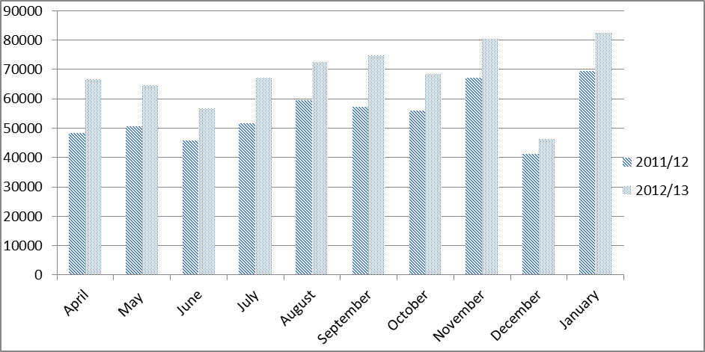

Total user numbers 1st April 2011– 31st January 2012 = 546009
Total user numbers 1st April 2012– 31st January 2013 = 679081
Total Increase/decrease % = +24%

This 24% increase is broken down as follows:
- 7% - Closure of Dingwall swimming pool 2011 / reopening of pool and refurbishment of fitness suite 2012
- 2% - Closure of Lochbroom swimming pool 2010.11 / reopening 2011.12
- 3% - Increase in fitness class provision at Lochaber Leisure Centre since refurbishment last quarter of 2011
- 12% - Overall increase in fitness programmes

